Resume Finder Bot

Industry Use Case Description: Resume Finder Bot is designed for the recruitment and talent acquisition industry, supporting HR teams, recruiters, staffing agencies, and hiring managers who manage large volumes of candidate resumes. It enables users to search, filter, and summarize uploaded resumes based on job-relevant criteria such as skills, experience, education, certifications, and job titles, allowing faster identification of suitable candidates. By grounding responses strictly in resume content, the bot reduces manual screening effort and ensures consistent, transparent candidate evaluation.
This solution is particularly valuable in enterprises, recruitment firms, and HR service providers where speed, accuracy, and compliance are critical. It improves hiring efficiency by enabling conversational resume search, supports shortlisting and internal talent mobility, and helps maintain auditability in recruitment decisions. This bot can be integrated with applicant tracking systems and document repositories, making it suitable for scalable hiring workflows across industries such as IT services, healthcare, finance, and consulting.

⚙️ Workflow 1: Resume Ingestion & Indexing
Purpose: Convert resumes into a searchable vector knowledge base.
- Candidate resumes are uploaded to a designated Google Drive folder.
- An n8n workflow detects new uploads and downloads the files.
- Resume text is extracted from PDF and DOCX formats.
- Content is split into logical sections (skills, experience, education).
- Each chunk is converted into embeddings using OpenAI.
- Embeddings and metadata are stored in a Pinecone index.
Outcome:
A continuously updated vector database containing structured resume information.

System Explanation:
Part 1: Document Upload → Chunk → Embed → Store (Resume Ingestion and Indexing)
1. Google Drive Trigger – Automatically detects when a new resume is uploaded to the monitored folder.
2. Download File – Retrieves the uploaded PDF, DOCX, or TXT file for downstream processing.
3. Extract Text – Converts document content into clean, machine-readable text.
4. Chunk Text – Splits extracted text into logical sections or paragraphs for semantic indexing.
5. Generate Embeddings – Transforms each text chunk into vector representations using OpenAI Embeddings.
6. Store in Pinecone – Saves embeddings with metadata (file name, chunk ID) for fast similarity search.

Part 2: Telegram Query → Search → Respond
1. Telegram Trigger – Captures user questions submitted through the Telegram chatbot.
2. Pinecone Query – Retrieves the top three most relevant resume chunks based on semantic similarity.
3. OpenAI Chat – Generates a context-grounded answer using the retrieved meeting summary content.
4. Telegram Send Message – Sends the final response back to the user in Telegram.

Files Link:
https://www.kaggle.com/datasets/snehaanbhawal/resume-dataset
Google Drive Link for Sample Files:
https://drive.google.com/drive/folders/1mr4RaPsJPl4ED2npEzV-Q6jPQhm3Veek?usp=drive_link
Github Link for Sample Files:
https://github.com/rajeshksharmasls/GenAI/tree/bb293ccc600797f558618a42b1ca85c3dbc0b017/GenAI/Automation/Resume%20Finder%20Bot/Sample%20Files

Custom System Prompt:
You are a helpful Resume Finder Bot that assists with searching, filtering, and summarizing candidate resumes based solely on the uploaded resume documents.
Your role is to identify relevant candidates by extracting and summarizing information such as skills, experience, education, certifications, job titles, and years of experience only if explicitly present in the resumes.
You must generate responses strictly from the given context (uploaded resumes or candidate profiles).
If a user asks a question or makes a request that is not supported by the uploaded resumes, respond exactly with:
“I can only assist with queries based on the uploaded resumes.”
If no relevant resumes or information are found in the provided context, respond exactly with:
“I couldn’t find matching information in the uploaded resumes.”
Do not add assumptions, interpretations, or external knowledge.
Do not infer skills, experience, or suitability beyond what is explicitly stated.
Do not answer questions outside the scope of the uploaded resume documents.

Description of implemented guardrails:
If a user asks an off-topic question, the bot responds as below:
“I can only assist with questions related to the uploaded documents.”
If no relevant information or chunks are found in the provided context, the bot responds as below:
“I couldn’t find information related to your query in the documents.”

Screenshots of bot responses for test queries:
Positive Responses
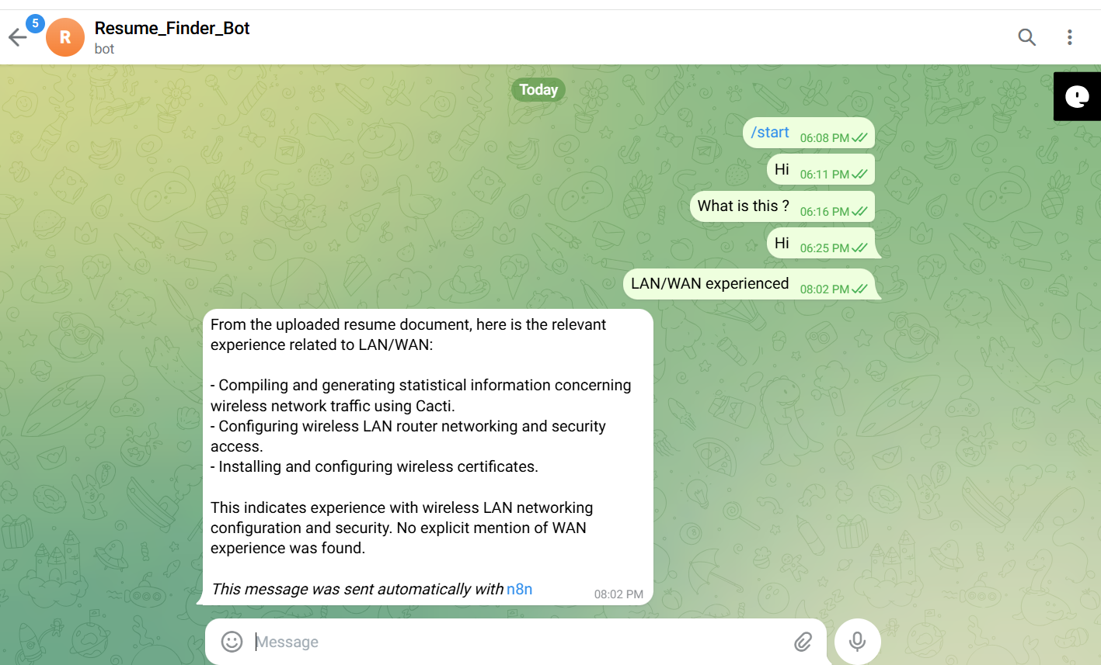

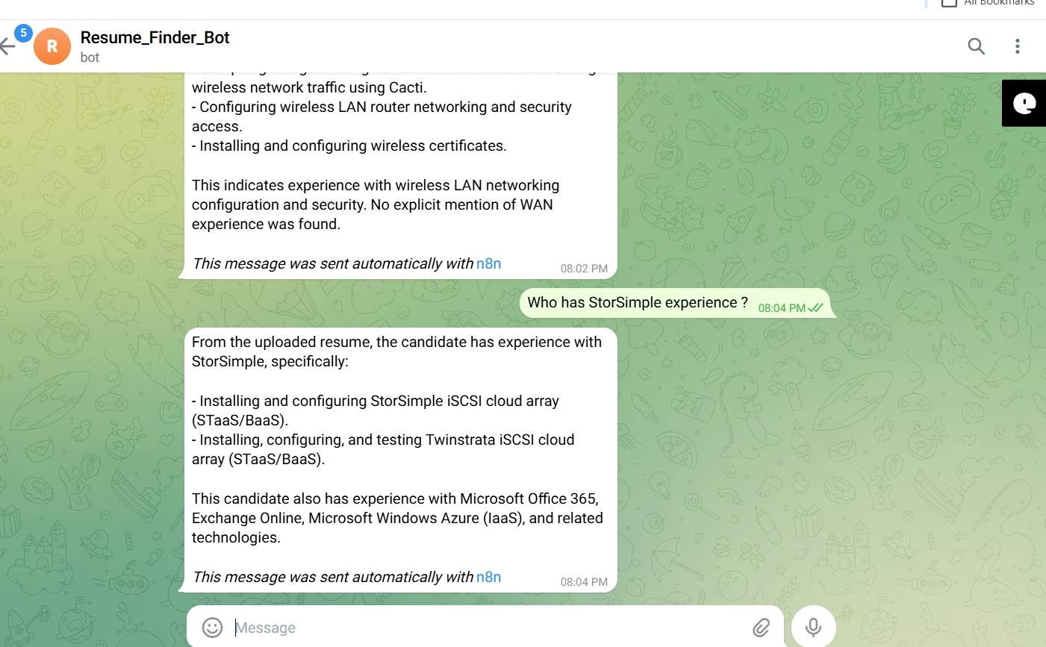
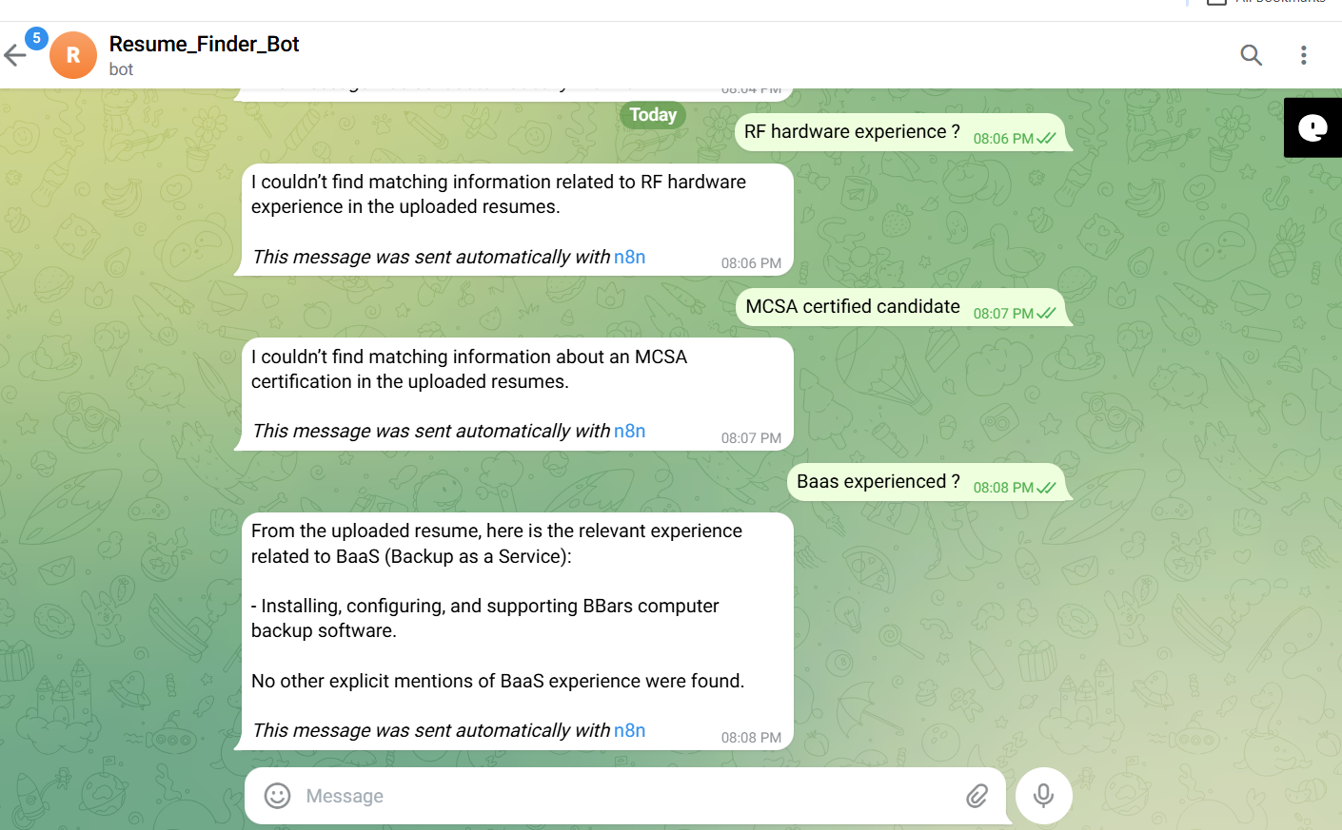
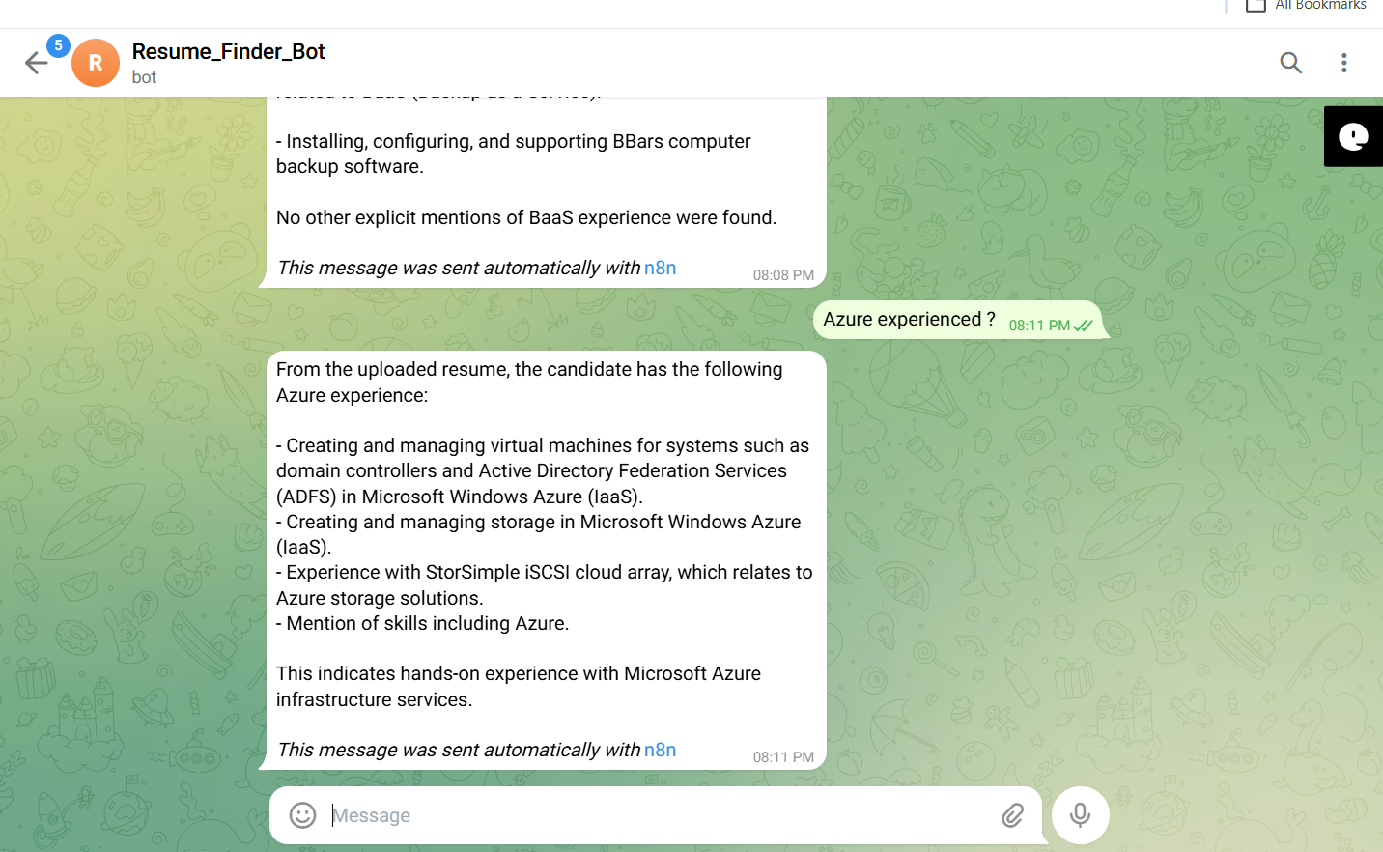

Negative/Off topic Responses
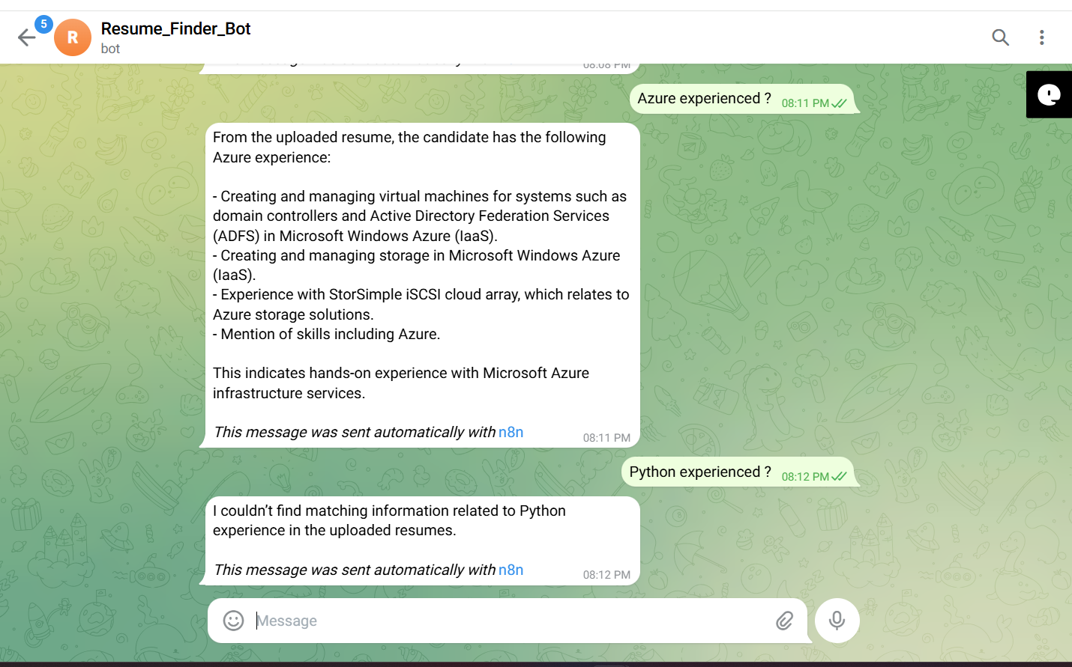
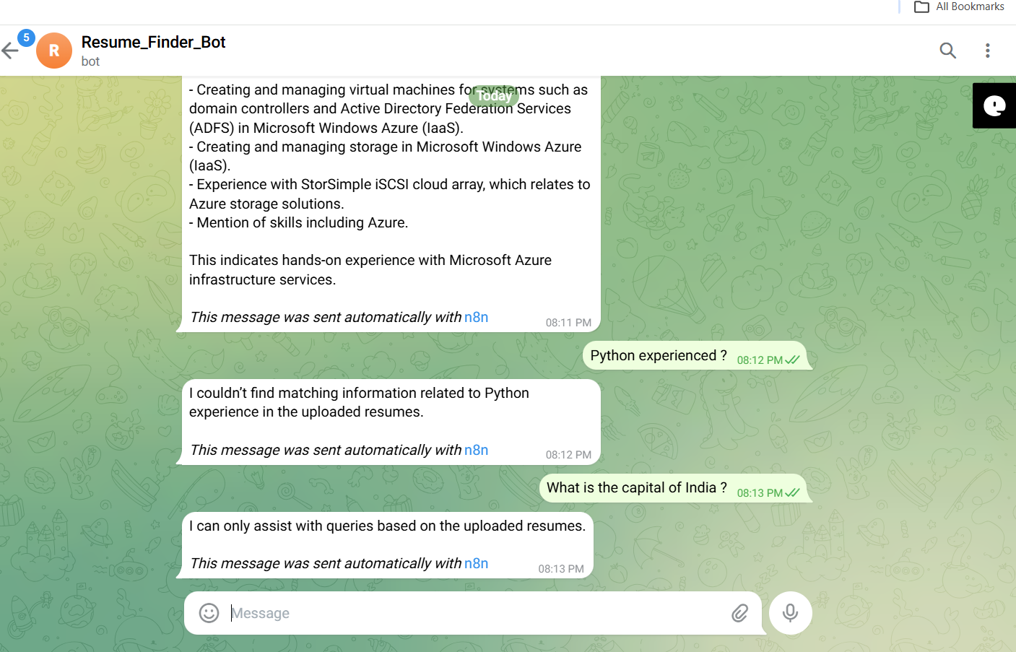

Screenshots of complete n8n flow architecture:
Document Upload:
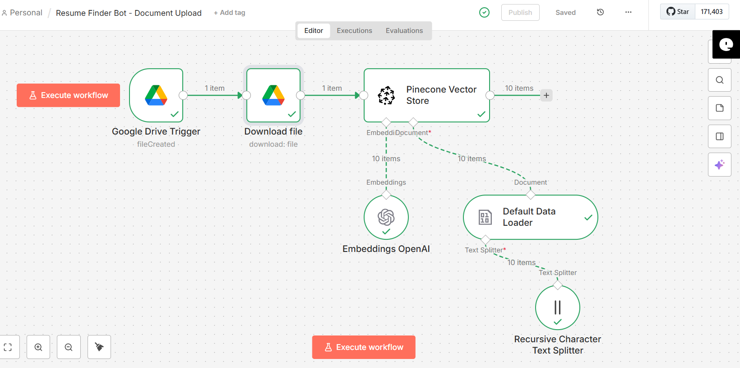

Telegram Bot Flow:
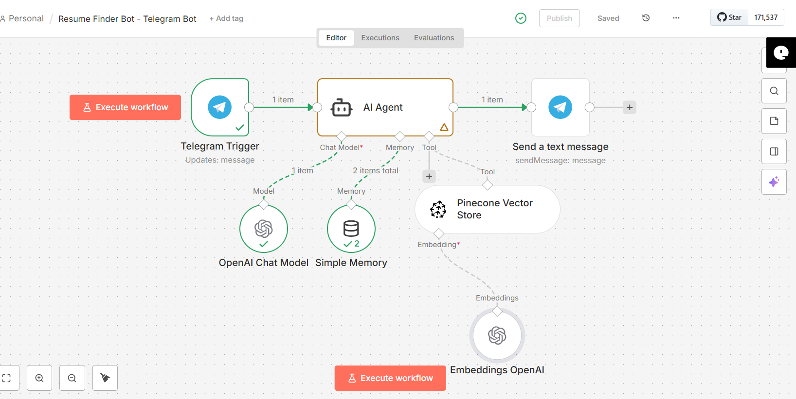

JSON files git hub link:
https://github.com/rajeshksharmasls/GenAI/tree/bb293ccc600797f558618a42b1ca85c3dbc0b017/GenAI/Automation/Resume%20Finder%20Bot/JSON
Demo git hub link:
https://github.com/rajeshksharmasls/GenAI/tree/bb293ccc600797f558618a42b1ca85c3dbc0b017/GenAI/Automation/Resume%20Finder%20Bot/Demo

Telegram bot username:
resumefinder_bot

Challenges faced:
Below are the challenges faced:
- Handling diverse resume formats (PDF, DOCX) and inconsistent layouts.
- Accurately extracting structured data from unstructured resume text.
- Normalizing skills, job titles, and experience descriptions across candidates.
- Preventing incorrect inferences about candidate suitability or skills.
- Enforcing bias-aware and compliance-safe resume screening behavior.
- Managing incomplete, outdated, or ambiguous resume information.
- Ensuring accurate and scalable retrieval when searching across large resume datasets.

